Test Documentation

Manual Testing
User Story 8 | As an Admin, I want to be able to create new user’s, so that I can let other user’s use the application.
Test Case ID | 1
Description | Retrieve data for all user’s - Success
Given | - The Application Server and Database Server is running  - Postman REST Client Opened
When | - Set GET request  - Enter URL http://localhost/Cosmere/public/users  - Press send
Then | - HTTP Response 200 OK  - All database entries are displayed in JSON format
Test Status | Passed

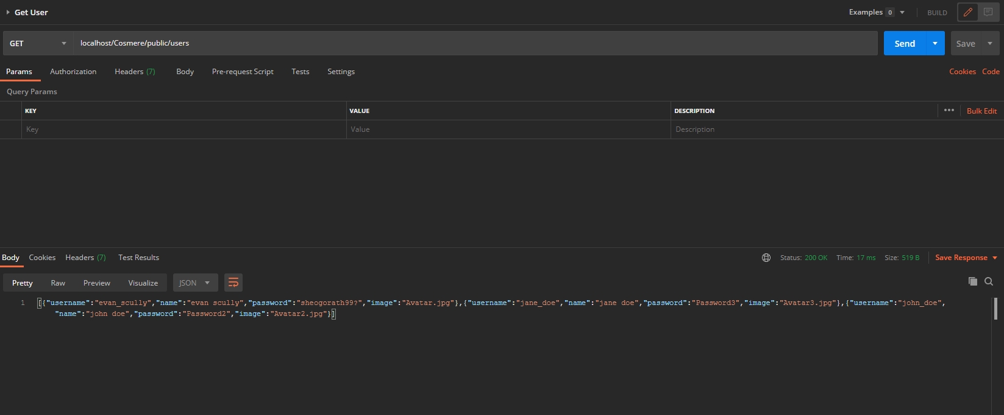

User Story 10 | As an API Consumer, I want to retrieve data in JSON format for one user based on its user name, so that I can use the data in my client application.
Test Case ID | 2
Description | Retrieve data based on ID - Success
Given | - The Application Server and Database Server is running  - Postman REST Client Opened
When | - Set GET request  - Enter URL http://localhost/Cosmere/public/user/1  - Press send
Then | - HTTP Response 200 OK  - Details for user’s displayed corresponding to entered ID
Test Status | Passed

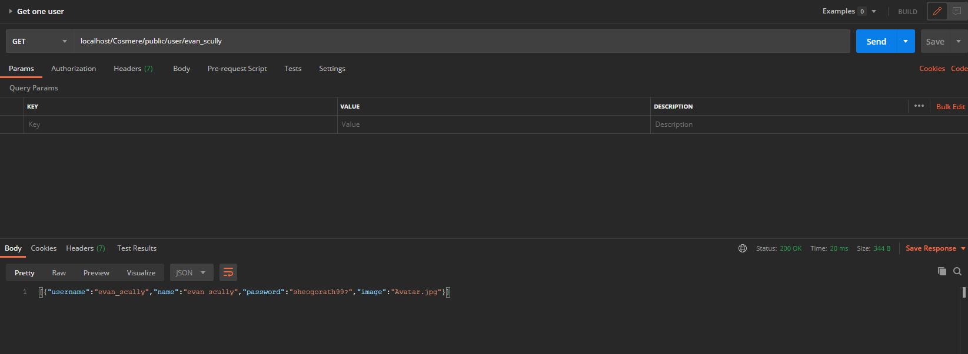

User Story 11 | As an Admin, I want to delete a user based on a given username, so that I can remove unwanted users through my client application.
Test Case ID | 3
Description | Delete data based on username - Success
Given | - The Application Server and Database Server is running  - Postman REST Client Opened
When | - Set DELETE request  - Enter URL  http://localhost/Cosmere/public/user/1  - Press send
Then | - HTTP Response 200  - Successfully deleted
Test Status | Passed

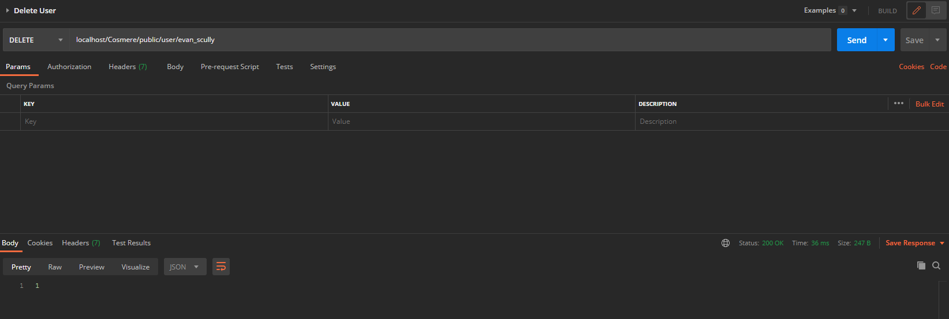
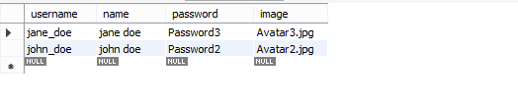

User Story 11 | As an Admin, I want to delete a user based on a given username, so that I can remove unwanted users through my client application.
Test Case ID | 4
Description | Delete data based on incorrect - Success
Given | - The Application Server and Database Server is running  - Postman REST Client Opened
When | - Set DELETE request  - Enter URL  http://localhost/Cosmere/public/users/56  - Press send
Then | - HTTP Response 200  - JSON dataset of 0
Test Status | Passed

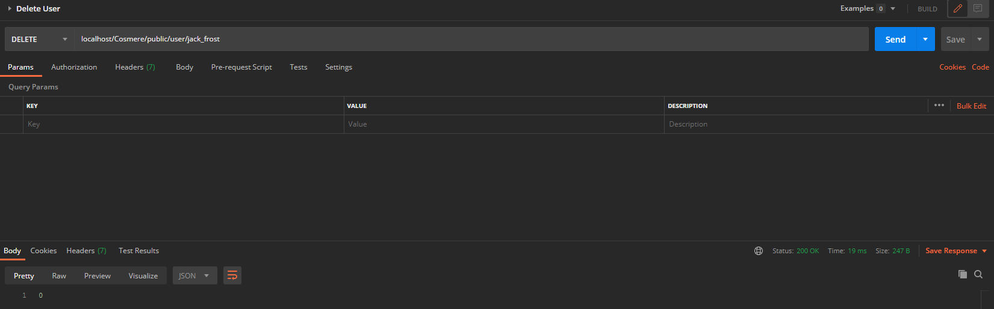

User Story 11 | As an API Consumer, I want to retrieve data in JSON format for one user based on its user name, so that I can use the data in my client application.
Test Case ID | 5
Description | Incorrect id is entered when retrieving a user’s - Success
Given | - The Application Server and Database Server is running  - Postman REST Client Opened
When | - Set GET request  - Enter URL  http://localhost/Cosmere/public/users/72  - Press send
Then | - HTTP Response 200  - Empty JSON data
Test Status | Passed

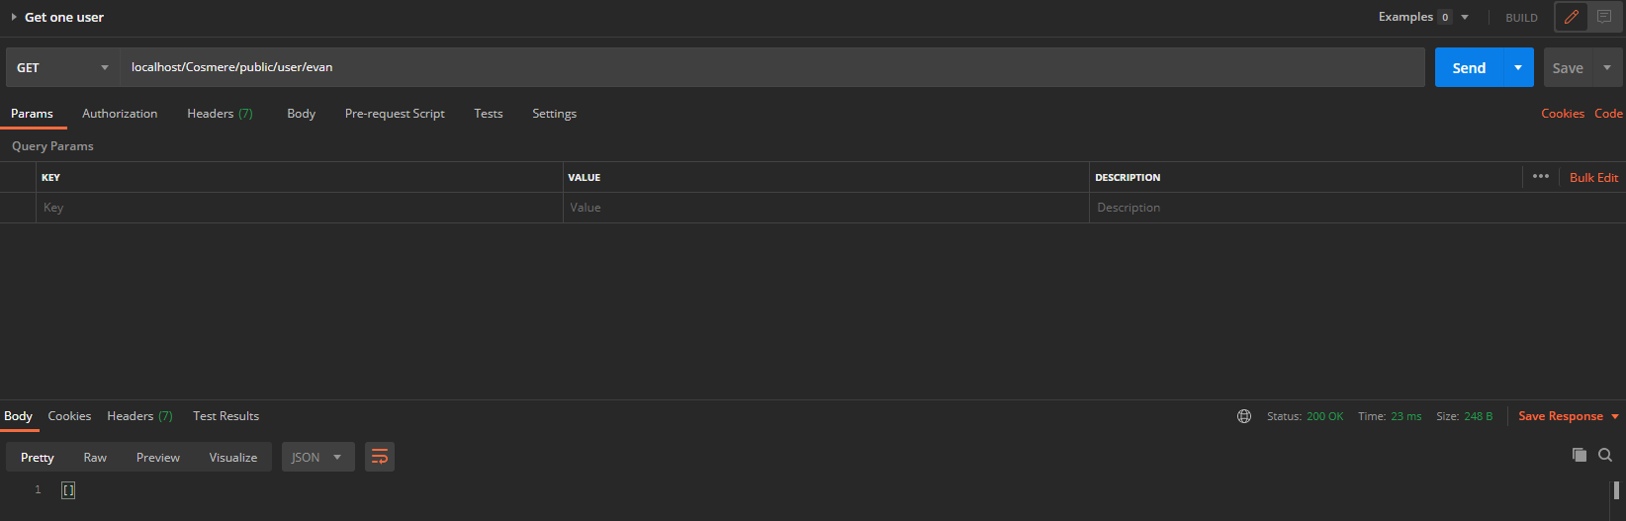

User Story 9 | As an User, I want to update my information , so that I can use the data in my client application.
Test Case ID | 6
Description | Update data based on username - Success
Given | - The Application Server and Database Server is running  - Postman REST Client Opened
When | - Set PUT request  - Enter URL  http://localhost/Cosmere/public/user/evan_scully  - Fill in x-www-form-urlencoded field in POSTMAN  - Press send
Then | - HTTP Response 200  - Successfully updated
Test Status | Passed

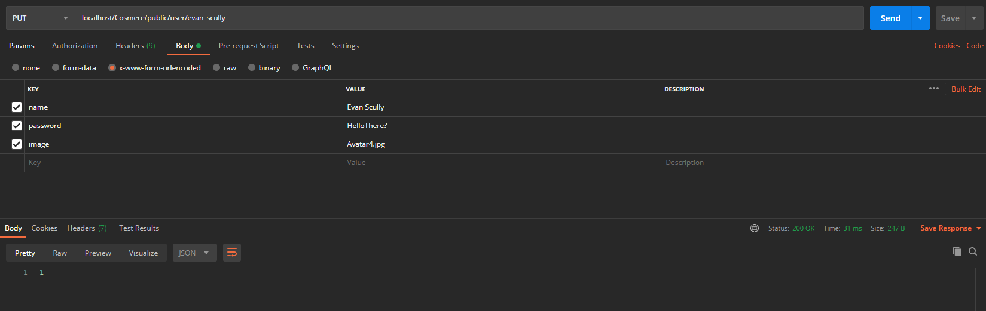
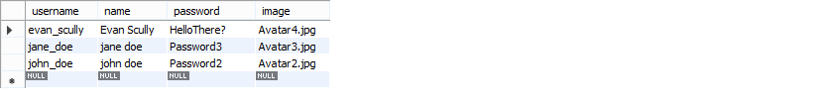

User Story 12 | As an Admin, I want to be able to create new users, so that I can let new people use the site and create profiles
Test Case ID | 7
Description | Add in a new user’s - Success
Given | - The Application Server and Database Server is running  - Postman REST Client Opened
When | - Set POST request  - Enter URL  http://localhost/Cosmere/public/user  - Fill in x-www-form-urlencoded field in POSTMAN  - Press send
Then | - HTTP Response 200  - Successfully deleted
Test Status | Passed

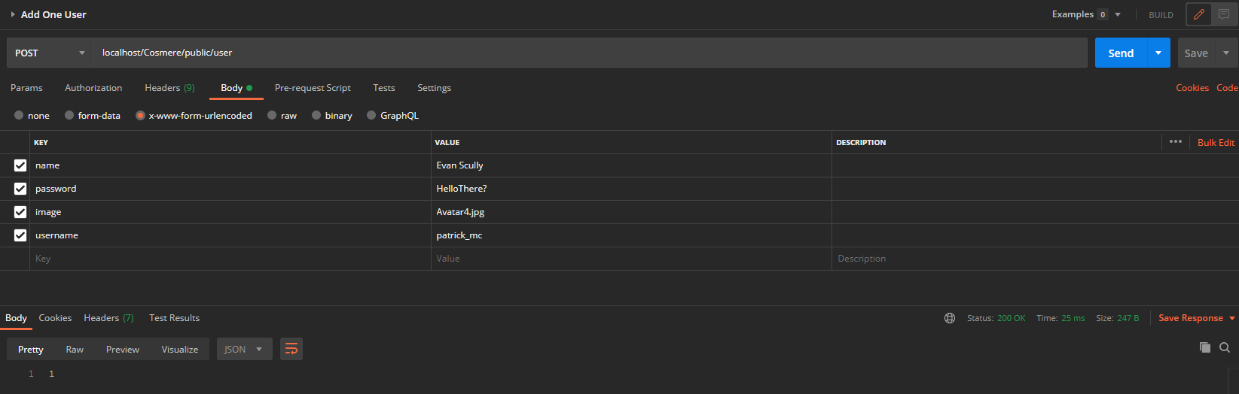
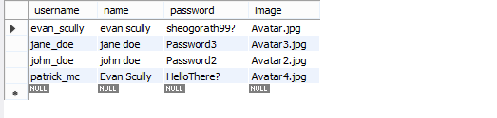

User Story 10 | As an API Consumer, I want to retrieve data in JSON format for one user based on its username, so that I can use the data in my client application.
Test Case ID | 8
Description | Incorrect username is entered when retrieving a user’s - Success
Given | - The Application Server and Database Server is running  - Postman REST Client Opened
When | - Set GET request  - Enter URL  http://localhost/Cosmere/public/users/jack_frost  - Fill in x-www-form-urlencoded field in POSTMAN  - Press send
Then | - HTTP Response 200  - JSON dataset of 0
Test Status | Passed

User Story 6 | As an API Consumer, I want to update a user’s for a specified id, so that I can use the data in my client application.
Test Case ID | 9
Description | Update data based on incorrect username - Success
Given | - The Application Server and Database Server is running  - Postman REST Client Opened
When | - Set PUT request  - Enter URL  http://localhost/Cosmere/public/user/evan_scully  - Fill in x-www-form-urlencoded field in POSTMAN  - Press send
Then | - HTTP Response 200  - JSON dataset of 0
Test Status | Passed

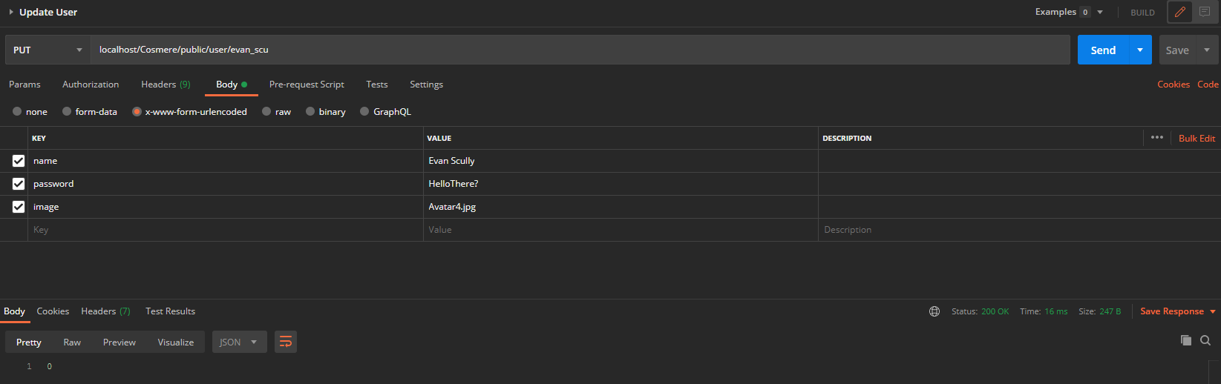

Test Report Summary

Test Type | Number Passed | Number Failed
Manual | 9 | 0

Bug Report
There are currently no known existing bugs in this project.

